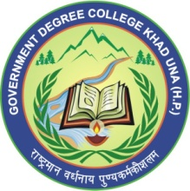 | GOVT. DEGREE COLLEGE, KHAD  Teh. Haroli, Distt. Una (Himachal Pradesh) 177207  Email: gdckhad2016@gmail.com Mob. 94182 96604

No. EDN-GCK-UNA- dated:

Office Order

Dr./Sh./Smt./Miss/……………..………………………, Designation ………..…………….., in the Department of …………………… He/She is directed to accompany with the college team for H.P. University Inter College Championship……………………………… to be held on w.e.f. ……………… to……………. at Govt./Pvt. College ……………………...………… Distt.………….., H.P.
He/She is relieved from his/her duties on ……………… (A.N./F.N.) and directed to report to Principal in above address.
He/She will be entitled for TA/DA as per admissible.

Principal
Govt. Degree College, Khad

Copy for information and necessary action to: -
1. The Principal, Govt./Pvt. College………………………... Distt…………….. H.P.
2. Concerned Official.
3. Accountant internal.

